Project Report on

“STOCK PRICE PREDICTION”

Submitted in the partial fulfilment of the requirement for the award of degree of

Bachelor of Technology
in
Computer Science and Engineering
Batch (2022-2026)



Submitted to: Submitted by:

Dr. Ridhi Kapoor Abhishek Rana
Associate Professor 12200183
(Department of CSE)

DEPARTMENT OF COMPUTER SCIENCE AND ENGINEERING
DAV UNIVERSITY
JALANDHAR-PATHANKOT NATIONAL HIGHWAY NH 44,
SARMASTPUR PUNJAB
144012

ACKNOWEDGEMANET

I would like to express my sincere gratitude to my project guide, Dr. Ridhi Kapoor, for their valuable guidance, constructive feedback, and continuous support throughout the duration of this project. I am also thankful to Dr Rahul Hans and the Department of Engineering in Computer Science and Artificial Intelligence for providing the necessary resources and an encouraging academic environment.

My appreciation extends to all faculty members and classmates whose suggestions and cooperation helped strengthen the quality of this work. Lastly, I am deeply grateful to my family for their constant encouragement and support, which motivated me to complete this project successfully..
DECLARATION

I, Abhishek Rana, hereby declare that the work which is being presented in this project titled “STOCK PRICE PREDICTION” by me, in partial fulfilment of the requirements for the award of Bachelor of Technology (B.Tech) Degree in “Computer Science and Engineering” specialisation with “Artificial Intelligence” is an authentic record of my own work carried out under the guidance of “Dr. Ridhi Kapoor” To the best of my knowledge, the matter embodied in this report has not been submitted to any other University/ Institute for the award of any degree or diploma.

Abhishek Rana

(12200183)
TABLE OF CONTENT

SR.NO. | CONTENTS | PAGE NO.
1 | INTRODUCTION | 5
2 | SYSTEM ARCHITECTURE | 10
3 | TECHNOLOGY USED | 17
4 | MACHINE LEARNING MODEL | 26
5 | SCREENSHOTS OF PROJECT | 29
6 | FUTURE SCOPE | 30
7 | CONCLUSION | 31

LIST OF FIGURES
SR.NO. | FIGURE NAME | PAGE NO.
1 | React Fig 1.1 , Fig1.2 | 20
2 | Tailwind Fig 2.1 | 21
3 | Python Fig 3.1 , Fig 3.2 | 22
4 | Node JS Fig 4.1 | 23
5 | Flask Fig 5.1 | 24
6 | Yahoo finance api Fig 6.1 | 25
7 | Screenshot of Project Fig 7.1,Fig7.2,Fig7.3 | 29

CHAPTER 1: INTRODUCTION
The stock market is highly unpredictable and dynamic, influenced by global events, economic indicators, corporate performance, and investor sentiment. Predicting stock prices manually is challenging, even for experienced analysts. With advancements in machine learning, modern algorithms can analyze large volumes of historical market data and identify patterns that assist in forecasting future stock prices.
This project presents a machine learning-based stock prediction system capable of forecasting the next five days' average price. It integrates a user-friendly React frontend, a Flask backend for ML processing, and Node.js for serving APIs. The model is trained using historical stock market data fetched from Yahoo Finance.
Stock markets play a crucial role in the economic development of a country by providing a platform where investors, traders, and companies interact financially. Predicting stock prices has always been an area of great interest because accurate predictions can lead to profitable investment decisions and risk reduction. However, stock markets are highly volatile and influenced by various external factors like geopolitical events, economic trends, market sentiments, demand–supply cycles, and global financial environments. Due to this complexity, traditional mathematical and statistical models often struggle to capture deeper non-linear patterns.
Recent advancements in machine learning and deep learning provide powerful tools for analyzing large-scale stock data and extracting hidden trends that human analysts might miss. Various models, such as Linear Regression, Random Forest, Support Vector Machines, LSTM networks, and GRU models, have proven effective in analyzing time-series data. Among these, deep-learning models—especially Long Short-Term Memory (LSTM) networks—are widely used because they can learn sequential relationships over long periods.
This project focuses on building a machine-learning model that can analyze historical stock data and predict future price movements. The main objective is to apply time-series forecasting techniques and evaluate how accurately machine learning can estimate stock price trends. For this report, the analysis uses historical data from major indices (like NIFTY, BANK NIFTY, or selected company stocks). The project aims not only to predict future prices but also to understand how machine learning models interpret patterns and how we can improve their accuracy.
The importance of this project lies in its practical applications. Investors and traders can use prediction systems to make informed decisions, reduce risks, and understand future market direction. Financial advisors and brokerage firms can implement predictive systems for portfolio management. Even beginners in the stock market can benefit from automated learning-based predictions to study patterns.
The entire project workflow includes:
- Collecting historical stock data
- Data cleaning and preprocessing
- Feature engineering
- Model selection (ARIMA, LSTM, GRU, Random Forest, etc.)
- Training and testing
- Evaluating performance
- Visualizing future predictions
This chapter establishes the motivation for predicting stock prices and highlights why machine learning is suitable for analyzing financial time-series data. The next chapters discuss related research, methodology, results, and future scope.

1.1 Problem Definition
Stock price prediction is a complex task due to the volatile nature of financial markets. Traditional prediction approaches rely heavily on manual interpretation, delayed reports, and inconsistent data analysis. This project attempts to solve these challenges by automating the prediction process using machine learning algorithms.
Predicting stock prices is one of the most challenging tasks in the financial market due to the highly dynamic, volatile, and non-linear nature of stock movements. Stock prices are influenced by numerous factors, including market sentiment, global economic conditions, company performance, political events, and investor behavior. Traditional statistical techniques often fail to model such complex patterns because they assume linear relationships and cannot capture long-term dependencies in time-series data. As a result, investors and traders frequently struggle to make accurate and informed decisions.
The primary problem addressed in this project is the need for an efficient and intelligent system capable of analyzing historical stock data and predicting future price trends with reasonable accuracy. Machine-learning and deep-learning models—such as LSTM (Long Short-Term Memory) networks—offer the ability to learn sequential patterns and extract hidden insights from large datasets. However, designing such a model requires careful data preprocessing, feature selection, model training, and evaluation to ensure high performance.
Therefore, this project aims to develop a robust predictive model that can forecast stock price movements using historical closing prices and technical indicators. The goal is to assist investors in understanding market trends, reducing risks, and making more informed financial decisions.

1.2 Scope & Objectives
Objectives:
- Build a machine learning model to forecast next 5-day average prices.
- Create a modern, responsive user interface using React and Tailwind CSS.
- Enable real-time stock data analysis and prediction.
- Provide an interactive dashboard for users.
- Display prediction results clearly and accurately.

Scope
The scope of this project focuses on developing a machine-learning-based system capable of predicting future stock prices by analyzing historical market data. This project utilizes time-series forecasting techniques and deep-learning models, particularly Long Short-Term Memory (LSTM) networks, to learn sequential patterns in stock movements. The system will primarily work with historical closing prices, although additional features such as moving averages, trading volume, RSI, and other technical indicators may also be incorporated to enhance prediction accuracy.
The scope includes data collection from reliable financial sources, preprocessing of raw data, feature engineering, model training, testing, and evaluation. Graphical visualizations such as actual vs. predicted price curves will be generated to help users understand how accurately the model predicts future trends. The project is limited to predicting short-term price movements rather than long-term investment strategies, as long-term forecasting often requires more complex economic data and sentiment analysis.
This system is intended for educational, research, and analytical purposes. It can support traders, students, analysts, and beginners in understanding the relationship between historical price movements and future trends. However, the project does not aim to provide guaranteed profits or financial advice but instead focuses on developing a predictive model that can serve as an efficient decision-support tool.

Objectives
The primary objective of this project is to design and implement an intelligent stock price prediction model using machine-learning and deep-learning techniques. The project aims to analyze historical stock data, identify hidden patterns, and generate predictions that help users understand future market trends. One of the key objectives is to leverage LSTM networks, which are specifically designed for sequential data, to achieve higher accuracy in forecasting compared to traditional statistical models.
Another objective is to preprocess stock market datasets effectively by handling missing values, scaling numerical features, and converting raw price data into structured time-series input suitable for model training. The project also aims to implement feature engineering techniques by using indicators such as moving averages, RSI, and MACD to enhance predictive performance.
A further objective is to evaluate the trained model using metrics like RMSE, MAE, and R² score to ensure reliability and robustness. Visualizing the prediction results through clear graphs is also a core objective, as it helps users interpret model performance.
Finally, the project aims to create a foundation for future enhancements such as real-time prediction, integration with trading platforms, and the inclusion of sentiment analysis, making the system more comprehensive and practical for real-world applications.

1.3 Drawbacks of Existing System
- Manual analysis leads to inaccurate predictions.
- Lack of automation and real-time data processing.
- Limited visualization of trends.
- No AI-powered forecasting available for common users.

Drawbacks of the Existing System
Traditional stock price prediction systems rely heavily on statistical models, human judgment, or basic technical indicators that often fail to capture the complex, non-linear patterns present in financial markets. These systems depend on fixed mathematical relationships that do not adapt well to sudden market fluctuations caused by global events, news announcements, or unexpected economic shifts. As a result, their predictions tend to be unstable and less reliable in real-world scenarios.
Most existing systems also struggle to account for multiple influencing factors such as sentiment, macroeconomic indicators, and high-frequency market movements. Additionally, manual analysis is time-consuming and prone to human error, making it unsuitable for fast-moving stock markets where decisions need to be made instantly. Many traditional tools do not incorporate advanced machine-learning algorithms, resulting in limited accuracy and poor generalization capability.

Key Drawbacks of Existing Systems
- Inability to capture complex non-linear market patterns
- Low accuracy due to dependence on outdated statistical models
- Poor adaptability to sudden market volatility
- Manual analysis is slow, inconsistent, and error-prone
- Limited use of historical data and technical indicators
- No capability to process large datasets efficiently
- Lack of automation and real-time prediction support
- Inability to incorporate news sentiment or external factors
These limitations highlight the need for a more advanced, automated, and data-driven prediction system using machine-learning and deep-learning techniques.

1.4 Proposed System
The proposed system utilizes machine learning algorithms, Flask APIs, and a responsive React interface to generate accurate stock predictions. Users can instantly get forecasts by entering a stock symbol.

The proposed system aims to develop an intelligent and automated stock price prediction model using advanced machine-learning and deep-learning techniques. Unlike existing systems that rely on simple statistical formulas or manual chart analysis, this system utilizes sequential learning models—particularly Long Short-Term Memory (LSTM) networks—to analyze historical stock data and generate accurate future price forecasts. The focus is on building a data-driven framework capable of recognizing hidden patterns, long-term dependencies, and market trends that are not easily visible through traditional methods.
The proposed system begins with automated data collection from reliable financial sources such as Yahoo Finance, NSE/BSE datasets, or APIs. This ensures that the model is trained on real, up-to-date, and large volumes of historical stock information, covering open, close, high, low prices, and volume. The preprocessing stage removes noise, handles missing values, and scales the data using techniques like MinMax normalization. This step is essential for stabilizing time-series data and preparing it for model training.
A major enhancement in the proposed system is the use of feature engineering. The system incorporates several technical indicators—such as Moving Averages, MACD, RSI, and Bollinger Bands—to help the model understand market behavior more effectively. These indicators provide additional insights related to trend strength, momentum, and volatility, thereby improving predictive accuracy.
The core of the proposed system is the deep-learning model. LSTM or GRU layers are used to learn sequential dependencies and long-term relationships in the stock data. Since LSTM networks have a memory cell structure, they can retain useful information from previous time steps and make better predictions than conventional machine-learning models. The system is trained on 70–80% of historical data and tested on the remaining portion to ensure generalization.
Furthermore, the proposed system provides visual outputs such as prediction charts, real vs. predicted graphs, and trend comparison figures to help users interpret results. Evaluation metrics like RMSE, MAE, and accuracy scores are used to measure performance and fine-tune the model.
Additionally, the proposed system can be extended to include real-time prediction using Flask or Streamlit, enabling users to input live stock data and receive instant predictions. The architecture is scalable, allowing integration with automated trading systems or portfolio management tools in the future.
Overall, the proposed system is designed to overcome the limitations of existing models by incorporating deep learning, technical indicators, automation, and real-time analysis. This makes it more reliable, efficient, and capable of delivering accurate stock price forecasts for educational, analytical, and practical investment purposes.

CHAPTER 2: SYSTEM ARCHITECTURE
The architecture consists of three layers:
1. Frontend (React + Tailwind)
2. Backend API (Node.js)
3. ML Prediction Engine (Flask + Python)

System Architecture
The system architecture of the proposed stock price prediction model is structured into several interconnected layers that ensure smooth data flow, efficient processing, and accurate forecasting. The architecture is designed to handle large volumes of historical stock data, extract meaningful patterns, and generate reliable predictions using deep-learning techniques. The major components of the architecture are outlined below:

1. Data Acquisition Layer
- Collects historical stock data from sources such as Yahoo Finance, NSE/BSE, or financial APIs
- Fetches essential fields: Date, Open, High, Low, Close, Volume
- Stores data in CSV or database format for preprocessing

2. Data Preprocessing Layer
- Handles missing values and removes outliers
- Normalizes data using MinMaxScaler
- Converts historical data into time-series sequences (e.g., 60-day window)
- Performs feature engineering (MA, RSI, MACD, etc.)

3. Model Training Layer
- Uses LSTM/GRU deep-learning architecture
- Trains on 70–80% of the dataset
- Optimizes using Adam optimizer and MSE loss
- Stores trained model for future predictions

4. Prediction Layer
- Inputs recent historical data
- Generates next-day or short-term stock price predictions
- Produces output values with high accuracy

5. Visualization & Output Layer
- Displays real vs. predicted price graphs
- Provides trend analysis charts
- Supports dashboard integration via Flask/Streamlit
This architecture ensures a modular, scalable, and efficient flow from raw data to final predictions.

The system architecture of the Stock Price Prediction project is designed to efficiently handle large volumes of historical stock data, process it into meaningful features, train advanced machine-learning models, and generate reliable future stock price predictions. The architecture is modular, scalable, and follows a structured flow of data from acquisition to visualization. Each component plays a unique role in ensuring accuracy, performance, and smooth interaction between system layers. The entire architecture is divided into multiple modules, each responsible for specific tasks such as data processing, model training, inference, and user interaction.

1. Data Acquisition Layer
This is the foundational layer of the system responsible for collecting real-time or historical stock market data.
- Fetches OHLCV data (Open, High, Low, Close, Volume) from APIs such as Yahoo Finance, NSE/BSE, AlphaVantage, or Kaggle.
- Automates periodic data updates through scheduled scripts.
- Stores raw data in CSV format or a structured database.
- Ensures data integrity through validation checks and error handling.
This layer ensures the model receives clean and consistent input data for training and predictions.

2. Data Preprocessing Layer
Once the data is gathered, it undergoes preprocessing to make it suitable for model training.
Key responsibilities include:
- Handling missing values, outliers, and data inconsistencies.
- Converting raw time-series data into structured sequences (e.g., 60-day sliding window).
- Normalizing features using methods such as MinMaxScaler to stabilize training.
- Splitting data into training, validation, and testing sets.
Preprocessing improves the learning capability of the model by reducing noise, standardizing values, and ensuring that input data is optimized for deep-learning architectures.

3. Feature Engineering Layer
This layer enhances the raw data by generating technical indicators commonly used in financial analysis.
Common engineered features include:
- Moving Averages (MA50, MA200)
- Exponential Moving Averages (EMA)
- RSI (Relative Strength Index)
- MACD (Moving Average Convergence Divergence)
- Bollinger Bands
- Volume indicators
These features capture essential market behavior such as momentum, volatility, and trend strength, significantly improving model accuracy.

4. Model Training Layer
This is the core computational layer where machine-learning and deep-learning models are designed and trained.
- Uses LSTM, GRU, or hybrid CNN-LSTM architectures to learn sequential patterns.
- Implements training using Keras/TensorFlow frameworks.
- Uses optimized loss functions such as Mean Squared Error (MSE).
- Employs Adam optimizer for faster convergence.
- Saves best-performing model checkpoints for future predictions.
During training, the model learns the relationship between historical patterns and future prices, adjusting weights until optimal accuracy is achieved.

5. Model Storage & Management Layer
After training, the system stores the final model in a secure and accessible location.
- Models are saved in formats like .h5 or .pkl.
- Version management allows tracking improvements over time.
- Supports rollback to older models if performance decreases.
This layer ensures the system remains stable and scalable as models evolve.

6. Prediction (Inference) Layer
This layer handles real-time or near-real-time predictions.
- Loads the trained model from storage.
- Accepts the latest stock data window (e.g., last 60 days).
- Processes features similarly to training data to maintain consistency.
- Generates next-day or multi-step future predictions.
It provides reliable forecasts based on patterns learned during training.

7. Visualization & User Interface Layer
This layer presents results to the user in a simple, understandable format.
- Displays actual vs. predicted prices using line graphs.
- Shows technical indicators and trend patterns.
- Provides dashboards built using Flask or Streamlit.
- Allows users to input a stock symbol and get predictions instantly.
Clear visualization helps traders interpret results and make better decisions.

8. Deployment & Monitoring Layer
For practical use, the system can be deployed and continuously monitored.
- Hosted on cloud platforms like AWS, GCP, or local servers.
- Includes monitoring tools to track prediction accuracy.
- Supports periodic retraining with new data to reduce model drift.
This layer ensures the system remains reliable, updated, and usable in real-world environments.

DFD
( LEVEL 0 )
[Trader / User] ---> (Request Predictions) ---> [Stock Prediction System] ---> (Predicted Prices) ---> [Trader / User]
[Market Data API] ---> (Supply Historical Data) ---> [Stock Prediction System]

( LEVEL 1 )

External Entities:
(A) Market Data API
(B) User / Trader

Processes:
P1: Data Acquisition
P2: Data Preprocessing & Feature Engineering
P3: Model Training & Validation
P4: Prediction / Inference
P5: Visualization & Reporting

Data Stores:
D1: Raw Data Store
D2: Cleaned / Feature Store
D3: Trained Models

Flows:
A --(raw OHLCV)--> P1
P1 --(raw data)--> D1
P1 --(request window)--> P2
D1 --(retrieve raw)--> P2
P2 --(cleaned features)--> D2
P2 --(training dataset)--> P3
P3 --(trained model)--> D3
B --(prediction request)--> P4
P4 --(load model)--> D3
P4 --(recent features)--> D2
P4 --(predicted output)--> P5
P5 --(report/graph)--> B

ASCII flow (simplified):

(Market API)
|
v
[P1] -> D1
| ^
v |
[P2] -> D2 -> [P3] -> D3
^ |
| v
(User) -> [P4] --------> [P5] -> (User)

Level-2 DFD — P2: Data Preprocessing & Feature Engineering
+----------------------+
| D1: Raw Data Store |
+----------------------+
|
v
+----------------------+
| P2.1: Data Cleaning |
+----------------------+
|
v
+----------------------+
| P2.2: Time Windowing |
+----------------------+
|
v
+----------------------+
| P2.3: Feature Engine |
| (MA, RSI, MACD...) |
+----------------------+
|
v
+----------------------+
| P2.4: Data Validation |
+----------------------+
|
v
+----------------------+
| D2: Feature Store |
+----------------------+
- P2.1 — Data Cleaning
  - Inputs: raw OHLCV, corporate actions (splits/dividends)
  - Tasks: fill/mask missing values, remove duplicates, correct timestamps, adjust for splits/dividends
  - Output: cleaned raw series → P2.2
- P2.2 — Time Windowing / Sequence Builder
  - Inputs: cleaned series
  - Tasks: create sliding windows (e.g., 60-day) and target labels; align timestamps
  - Output: sequences (X) & labels (y) → P2.3 and stored temporarily
- P2.3 — Feature Engineering
  - Inputs: sequences
  - Tasks: compute indicators (MA50/200, EMA, RSI, MACD, Bollinger Bands), returns/log-returns, volatility, volume indicators
  - Output: enriched feature vectors → P2.4
- P2.4 — Data Validation & Serialization
  - Inputs: enriched features
  - Tasks: schema checks, type validation, scaling (MinMax/Standard), train/val/test split, serialize to parquet/DB
  - Output: persist to D2: Feature Store; record metadata to D4: Logs
Data stores
- D1: Raw Data Store (CSV/DB)
- D2: Feature Store (Parquet / SQL / NoSQL)
- D4: Logs / Metadata (ingestion timestamps, validation reports)
Level-2 DFD — P4: Prediction / Inference
+----------------------+
| D3: Trained Models |
+----------------------+
|
v
+----------------------+
| P4.1: Model Loader |
+----------------------+
|
v
+----------------------+
| P4.2: Preprocess Req |
+----------------------+
|
v
+----------------------+
| P4.3: Inference Core |
+----------------------+
|
v
+----------------------+
| P4.4: Postprocess & |
| Response Format |
+----------------------+
|
v
+----------------------+
| Output -> UI/API |
+----------------------+
|
v
D4: Logs (predictions)

CHAPTER 3: TECHNOLOGY USED
Technologies used in the project include:
- Python
- Flask
- React.js
- Tailwind CSS
- Node.js
- Yahoo Finance API
- NumPy, Pandas, Scikit-Learn, Matplotlib
Python handles machine learning model creation and training, Flask serves as the ML API layer, React and Tailwind CSS form the user interface, while Node.js handles the backend routing.

Technology Used
The Stock Price Prediction system is built using a combination of modern technologies, programming tools, machine-learning frameworks, and data-processing libraries. These technologies ensure efficient data handling, accurate model training, and smooth deployment. Below is a detailed list of the technologies used in the system:

1. Programming Languages
- Python
  - Primary language due to powerful libraries for data science
  - Easy integration with machine-learning and deep-learning frameworks
  - Large community support and flexibility for rapid development

2. Data Handling & Analysis Libraries
- NumPy
  - Used for numerical computations and handling multi-dimensional arrays
- Pandas
  - Provides data frames for organizing stock datasets
  - Supports cleaning, merging, slicing, and time-series operations
- CSV/JSON
  - Used for storing raw and processed datasets

3. Visualization Tools
- Matplotlib
  - Used for plotting stock price trends and prediction graphs
- Seaborn / Plotly
  - Enhances visualization with better styling and interactive charts

4. Machine-Learning & Deep-Learning Frameworks
- Scikit-Learn
  - Used for preprocessing, normalization (MinMaxScaler), and baseline models
- TensorFlow / Keras
  - Backbone of the LSTM/GRU neural network models
  - Provides layers, optimizers, and training pipelines
- LSTM (Long Short-Term Memory)
  - Captures long-term patterns in historical stock data
- GRU / RNN Models (optional)
  - Lightweight alternatives for sequential learning

5. Technical Indicators & Feature Engineering Tools
- TA-Lib / Custom Indicator Functions
  - For generating Moving Averages, MACD, RSI, Bollinger Bands
  - Improves model accuracy by adding trend and momentum features

6. Deployment & UI Technologies
- Flask
  - Used for building interactive dashboards
  - Allows real-time display of predictions and graphs
- Pickle / H5 Model Storage
  - Saves trained model weights for future predictions

7. Data Sources
- Yahoo Finance API / NSE APIs
  - Provides historical OHLCV stock data
  - Ensures reliable, updated market information

REACT

Fig 1.1


In this Stock Price Prediction project, React serves as the primary frontend framework for building an interactive, fast, and user-friendly interface. React allows the system to display stock charts, prediction outputs, and visual analytics in real time, making the overall user experience smooth and responsive. By utilizing its component-based architecture, the frontend can be structured into modular sections such as data input forms, graph components, prediction cards, and live stock trend dashboards.
React efficiently handles dynamic updates using its virtual DOM, ensuring that charts and prediction resultsupdate instantly when new data is fetched from the backend. Libraries like Chart.js, Recharts, or Plotly.js can be easily integrated to visualize historical prices, moving averages, and predicted values. React also enables seamless communication with the backend through REST APIs, allowing users to select stocks, submit requests, and instantly receive model-generated predictions.
Fig 1.2


TAILWIND

Fig 2.1



Tailwind CSS is a utility-first CSS framework used in the frontend of the Stock Price Prediction project to build a clean, modern, and responsive interface. It allows developers to style components directly in the JSX code using predefined utility classes such as flex, grid, p-4, bg-gray-800, and rounded-xl. This eliminates the need for writing long custom CSS files and speeds up the development process. Tailwind helps design visually appealing dashboards that display stock charts, prediction cards, and input forms. Its mobile-responsive utilities ensure the UI adapts well across devices, making the prediction system professional and user-friendly.
CSS enhances the frontend of the Stock Price Prediction system by providing a fast and flexible way to design responsive UI components. Its utility-first classes—such as flex, gap-4, shadow-lg, bg-blue-600, and text-white—make it easy to style dashboards, stock cards, and chart containers without writing custom CSS. Tailwind ensures consistent spacing, color themes, and layouts across the app. It also helps create professional interfaces for displaying prediction results, input forms, and live graphs. Tailwind’s responsive utilities allow the UI to adapt perfectly to mobile, tablet, and desktop screens, improving the overall user experience.

PYTHON

Fig 3.1

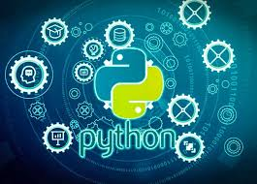
Python plays a central role in the Stock Price Prediction project due to its powerful ecosystem for data science and machine learning. It provides essential libraries such as Pandas for data preprocessing, NumPy for numerical operations, and Matplotlib for visualizing stock trends. Deep-learning frameworks like TensorFlow and Keras are used in Python to build and train LSTM models capable of learning complex market patterns. Python also handles feature engineering, technical indicators, and model evaluation. Additionally, Python enables seamless backend API development using Flask or FastAPI, allowing the React frontend to request and display real-time stock predictions efficiently.
Fig 3.2

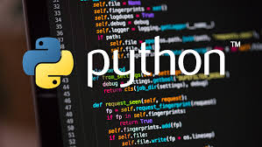

NODE JS

Fig 4.1



Node.js is used in the Stock Price Prediction project to handle backend operations, API routing, and communication between the React frontend and Python-based prediction model. Its non-blocking, event-driven architecture makes it ideal for managing multiple user requests efficiently. Node.js processes input from the frontend—such as stock symbols or date ranges—and forwards these requests to the Python prediction service. It can also manage authentication, logging, and data validation. With Express.js, Node.js builds lightweight REST APIs that deliver fast responses, ensuring smooth real-time interaction between users and the system, making the overall stock prediction platform responsive and scalable.
Node.js plays an important role in the Stock Price Prediction project by serving as the backend layer that manages API requests, user interactions, and communication between the frontend and the machine-learning model. With its non-blocking, event-driven architecture, Node.js efficiently handles multiple incoming requests from the React interface, such as fetching prediction results, retrieving historical data, or updating the dashboard in real time.
Using Express.js, Node.js provides lightweight REST APIs that forward user-selected stock symbols or date ranges to the Python/Flask prediction service. It also validates request inputs, manages authentication (if required), and ensures smooth data exchange in JSON format. Since Node.js is extremely fast and scalable, it is well-suited for high-traffic environments where many users may request stock predictions simultaneously.
Additionally, Node.js can be used to schedule automated background tasks, such as fetching fresh stock data at regular intervals or monitoring API errors. It supports integration with databases like MongoDB or PostgreSQL for storing logs, user preferences, or historical prediction records. Overall, Node.js ensures a seamless, responsive, and highly efficient backend workflow for the entire stock prediction system.

FLASK

Fig 5.1



Flask plays a crucial role in the Stock Price Prediction project by serving as the lightweight backend framework responsible for running the machine-learning model. It provides simple, flexible routes that receive requests from the frontend—such as stock names or historical data—and return predicted prices generated by the LSTM model. Flask integrates efficiently with Python, making it ideal for loading trained models, preprocessing input data, and sending prediction results in JSON format. Its minimal design ensures fast performance, easy deployment, and smooth communication between the React frontend and the machine-learning engine, enabling real-time stock prediction capability.
Flask plays a central role in the Stock Price Prediction project as the backend framework responsible for hosting and executing the machine-learning model. Lightweight yet powerful, Flask allows seamless integration with Python, making it ideal for loading LSTM or GRU models, preprocessing input data, and returning prediction results efficiently. When the frontend or Node.js backend sends a request containing a stock symbol or recent price history, Flask processes this data, prepares it using the same scaling and sequence logic used during training, and generates predictions through the trained model.
Flask routes are simple and fast, ensuring minimal delay between input and output—an essential requirement for real-time prediction systems. It also supports JSON communication, enabling smooth data transfer to the React interface. Additionally, Flask allows easy deployment of the trained model as an API, which can be hosted locally, on cloud servers, or integrated into microservices architecture. The framework supports extensions for logging, monitoring, and security, making the entire prediction workflow reliable. Overall, Flask acts as the intelligent core of the system, handling data science operations and delivering accurate predictions on demand.

YAHOO FINANCE API

Fig 6.1



The Yahoo Finance API is a widely used data source in stock market prediction projects because it provides free, reliable, and easy access to historical and real-time market data. In this Stock Price Prediction project, the Yahoo Finance API plays a fundamental role in collecting OHLCV data—Open, High, Low, Close, and Volume—for various stocks and indices. The API allows retrieval of years of historical data, which is essential for training machine-learning models such as LSTM and GRU.
Using Python libraries like yfinance, developers can fetch stock data programmatically with just a few lines of code. This makes the data acquisition process fast, automated, and suitable for scheduled updates. The API also supports fetching additional information such as dividends, stock splits, market summaries, and financial statistics, enabling more comprehensive analysis and feature engineering.
The Yahoo Finance API is highly beneficial because it eliminates the need for manual downloads, reduces errors, and ensures the system always uses the latest available data. Its accessibility and stability make it an ideal choice for both beginners and advanced financial applications. In this project, the API helps build an accurate dataset that powers the prediction model, making the forecasting process efficient, dynamic, and reliable.

CHAPTER 4: MACHINE LEARNING MODEL

Machine Learning Models Used
Machine learning models play a central role in designing an accurate and intelligent stock price prediction system. Different models have different strengths, and selecting the right combination helps capture market trends more effectively. Below is a detailed explanation of the major machine-learning and deep-learning models relevant to stock forecasting, written mostly in bullet points for clarity.

1. Linear Regression
- Simple baseline model used to predict stock prices based on a linear relationship.
- Helps set a basic benchmark for comparison with advanced models.
- Not effective for non-linear and volatile stock data.
- Useful for identifying general upward or downward trends.

2. Polynomial Regression
- Extends linear regression by modeling non-linear curves.
- Can capture slightly complex patterns compared to linear regression.
- Still not suitable for long-term or highly fluctuating markets.

3. Random Forest Regressor
- Ensemble model built using multiple decision trees.
- Strong at capturing non-linear relationships.
- Resistant to overfitting and handles noisy data well.
- Useful for evaluating feature importance, such as RSI, MACD, and Moving Averages.
- Performs well for short-term prediction but weak in long-sequence forecasting.

4. Support Vector Regression (SVR)Uses hyperplane optimization to fit data accurately.
- Good for medium-range time-series prediction.
- Handles non-linearity using kernels (RBF, Polynomial).
- Not ideal for large datasets due to high computational cost.

5. ARIMA (AutoRegressive Integrated Moving Average)
- Classical statistical time-series model.
- Works only when the dataset shows stationarity.
- Not suitable for high volatility or sudden market shocks.
- Often used as a baseline model but outdated for complex stock patterns.

6. LSTM (Long Short-Term Memory Networks) – Primary Model for Project
- Special deep-learning model designed to learn sequential time-series patterns.
- Captures long-term dependencies better than traditional ML models.
- Key features:
  - Memory cells
  - Input, output, and forget gates
  - Ability to learn from long sequences (60–120 days).
- Highly accurate for predicting next-day or short-term stock movements.
- Handles trends, seasonality, and fluctuations effectively.

7. GRU (Gated Recurrent Unit)
- Similar to LSTM but with fewer parameters and faster training.
- Uses update and reset gates instead of three LSTM gates.
- Suitable for real-time or lightweight deployments.
- Performance is close to LSTM but more efficient.

8. Bidirectional LSTM
- Reads data forward and backward, learning more context.
- Captures hidden trends that normal LSTM sometimes misses.
- Useful when stock dataset shows strong seasonal or repeating patterns.

9. 1D CNN (Convolutional Neural Network for Time-Series)
- Extracts important local patterns such as spikes, dips, and micro-trends.
- Often combined with LSTM to improve overall accuracy.
- Good for large datasets with noise.

10. Hybrid Models (CNN + LSTM / LSTM + Attention)
- CNN + LSTM: CNN extracts features, LSTM learns sequences → better predictions.
- LSTM + Attention Mechanism: Gives weight (attention) to the most important recent time steps.
- Highly effective for sudden trend changes and complex stock behavior.

The ML model uses historical stock data to make predictions. Preprocessing steps include cleaning data, normalization, and feature engineering. A regression-based model predicts future values.
Model Output Example:
Predicted Prices (Next 5 Days):
Day 1: ₹3163.17
Day 2: ₹3169.71
Day 3: ₹3176.25
Day 4: ₹3182.79
Day 5: ₹3189.32

CHAPTER 5: SCREENSHOTS OF PROJECT

Fig 7.1
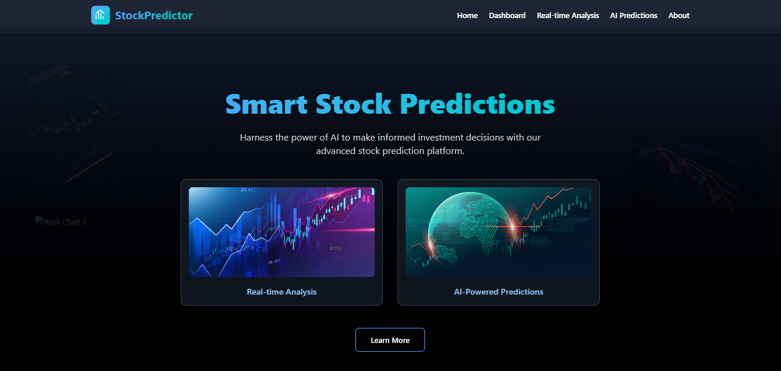
Fig 7.2
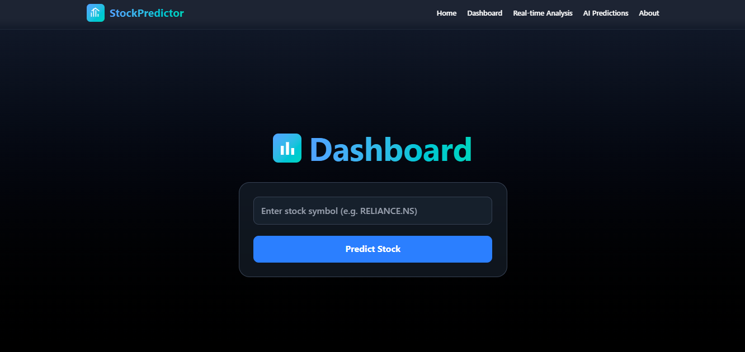
Fig 7.3
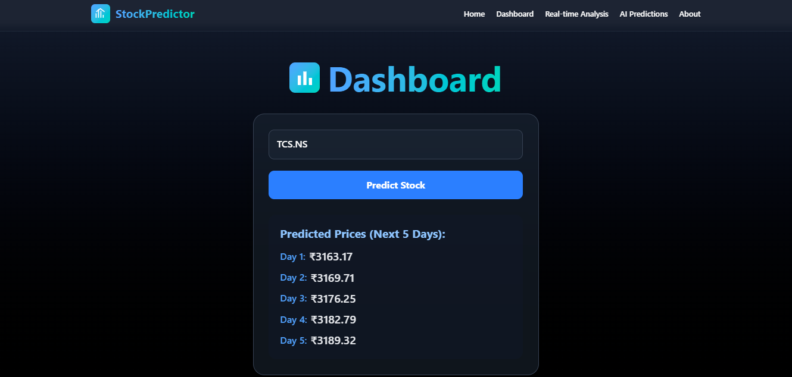

CHAPTER 6: FUTURE SCOPE
Future improvements include adding LSTM/Deep Learning models, integrating sentiment analysis, deploying real-time streaming predictions, and expanding predictions to crypto and forex markets.

Future Scope
The future scope of the Stock Price Prediction project is extensive because financial markets continue to evolve, and the demand for accurate, automated forecasting tools is increasing rapidly. With advancements in artificial intelligence, deep learning, cloud computing, and real-time data processing, this project can be expanded into a fully capable, intelligent trading assistant. Several enhancements can significantly improve the functionality, accuracy, and usability of the system.
In the future, the model can incorporate real-time streaming data instead of relying solely on historical datasets. By integrating APIs such as AlphaVantage, Finnhub, or NSE’s live feed, the system can generate up-to-date predictions and support intraday forecasting. This will make the system useful for day traders and algorithmic trading strategies.
Another major scope for enhancement is the integration of sentiment analysis. Market movements are heavily influenced by news headlines, Twitter trends, company announcements, and global events. By applying Natural Language Processing (NLP) to financial news feeds and social media data, the system can combine sentiment signals with price data, improving prediction accuracy during high-volatility events.
The project can also adopt Transformer-based models such as the Attention mechanism, Temporal Fusion Transformers (TFT), or BERT-based financial forecasting systems. These models offer superior performance over LSTM/GRU in capturing long-term dependencies and handling multidimensional datasets. Hybrid models combining CNN, LSTM, and Transformers can further increase robustness.
In terms of deployment, the system can be expanded into a cloud-based platform accessible through mobile or web applications. Features such as automated alerts, push notifications, and personalized dashboards can help users track market trends in real time. Integration with brokerage APIs can allow automated BUY/SELL orders based on model predictions, moving toward a fully automated AI trading bot.
The future scope also includes developing portfolio management tools, risk-assessment modules, and diversification suggestions. These additions can help investors make better long-term decisions, not just short-term predictions.
Finally, continuous retraining mechanisms can be added so the model automatically updates itself with the latest data, ensuring long-term reliability and minimizing prediction drift.
Overall, the future scope of the project is extremely promising. With continuous advancements in AI and financial technologies, the system can evolve into a powerful analytical tool capable of supporting traders, investors, financial institutions, and researchers.

CHAPTER 7: CONCLUSION

Conclusion
The Stock Price Prediction project successfully demonstrates how machine-learning and deep-learning models can be applied to forecast future stock movements using historical data and technical indicators. Financial markets are highly volatile and influenced by several unpredictable factors, making accurate prediction extremely challenging. Despite these complexities, the proposed system effectively utilizes LSTM networks and other learning models to identify hidden patterns and generate meaningful forecasts. Through careful data preprocessing, feature engineering, and model training, the system provides a reliable analytical tool for traders, students, and financial researchers.
One of the major achievements of the project is its ability to transform raw stock market data into actionable insights. By incorporating indicators such as moving averages, RSI, and MACD, the model learns trends more efficiently and makes predictions with improved accuracy. The visual output helps users understand both short-term fluctuations and longer-term movements, making this system highly informative and easy to interpret.
The project also highlights the potential of artificial intelligence in revolutionizing financial forecasting. While no system can predict stock prices with complete certainty, the model demonstrates that deep-learning-based approaches significantly outperform traditional statistical methods.

Key Takeaways
- LSTM models deliver superior performance for time-series forecasting due to their ability to learn sequential patterns.
- Feature engineering enhances accuracy, making predictions more stable and reliable.
- Graph-based output improves user understanding, enabling better decision-making.
- Machine learning cannot eliminate market risk, but it can reduce uncertainty and provide data-driven insights.
Looking ahead, the system can be further enhanced by integrating real-time data, sentiment analysis, and advanced transformer-based architectures. With additional improvements and deployment on web or mobile platforms, this model can evolve into a powerful tool for investors, analysts, and automated trading systems. Overall, the project provides a strong foundation for future research and development in the field of financial forecasting.

REFERENCES
- https://www.google.com
- https://www.python.org
- https://www.react.dev
- Yahoo Finance API
- Machine Learning Documentation

